# 1 .INTRODUCTION

OVERVIEW

As educational institutions strive to excel in a highly competitive landscape, the need for efficient management and organization has become paramount. From student admissions and enrollment to managing faculty and alumni relations, educational institutions face complex challenges that require a robust Customer Relationship Management (CRM) solution. Among the plethora of [CRM applications](https://solidperformers.com/best-crm-for-educational-institutions/) available, Solid Performers CRM has emerged as the top choice for schools and colleges seeking a [comprehensive solution](https://solidperformers.com/best-crm-for-educational-institutions/) to streamline operations and enhance productivity.

We have closely observed the evolution of CRM solutions and their impact on educational institutions. In this article, we will delve into the [unique features and benefits](https://solidperformers.com/solutions/) of Solid Performers CRM that make it the Best CRM Application for Schools and Colleges.

PURPOSE

Customer relationship management (CRM) systems facilitate transparency, productivity, and engagement across organizations. Within higher education, institutions rely on customer relationship management to engage with students before, during, and after enrollment.



Many CRM systems have similar features and cloud-based capabilities. Deciding on the right platform often comes down to how a school plans to leverage it, which personnel require access and the level of digital transformation that a school hopes to achieve.

This guide to CRM for higher education will describe what these tools do, why they are important, and how they influence the student journey. Keep reading for a list of CRM recommendations based on quality, features, and cost.

# 2. PROBLEM DEFINITION &DESIGN THINKING

EMPATHY MAP

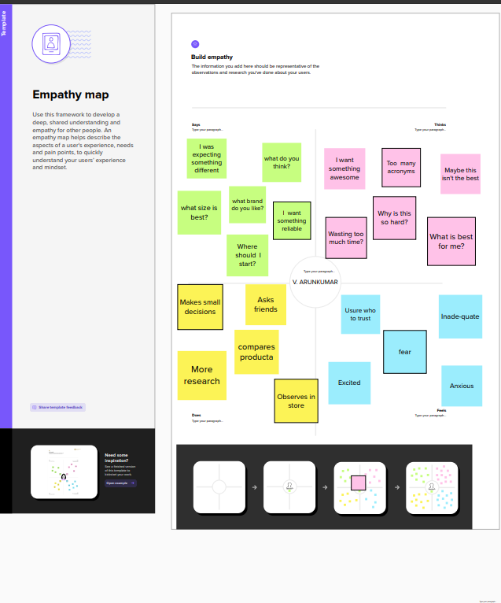

IDEATION & BRAINSTORM MAP

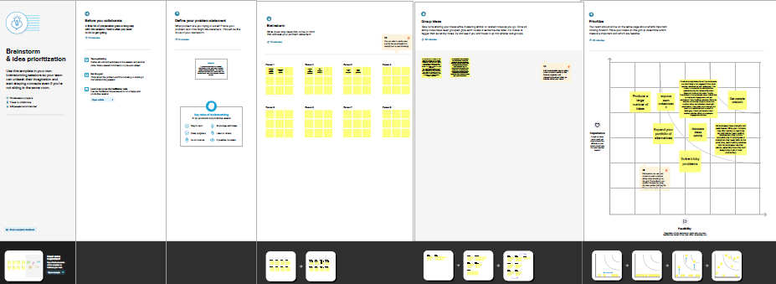

# 3. RESULT

DATA MODEL

|  |  |  |  |  |  |  |  |  |
| --- | --- | --- | --- | --- | --- | --- | --- | --- |
| OBJECT NAME | FIELD IN THE OBJECT | | | | | | | |
| Job posting sites | |  | | | | | | | |
|  | FIELD LABEL | | DATA TYPE | | |  | |
| Job posting site | | URL | | |
|  | | | | |
|  | | | | | | | |
| Technical sites |  | | |  | | |  | |
| FIELD LABEL | | DATA TYPE |
| Technical site | | URL |
|  | | |

# 

|  |  |  |  |  |
| --- | --- | --- | --- | --- |
| OBJECT NAME | FIELD IN THE OBJECT | | | |
| Status |  | | | |
|  | FIELD LABEL | DATA TYPE |  |
| Status | URL |
|  | | | |
| Description | |  |  | | --- | --- | | FIELD LABEL | DATA TYPE | | Description | URL | | | | |
| Job Posting | |  |  | | --- | --- | | FIELD LABEL | DATA TYPE | | Job posting | URL | | | | |

ACTIVITY & SCREENSHORT

Milestone-1: Creation of developer account

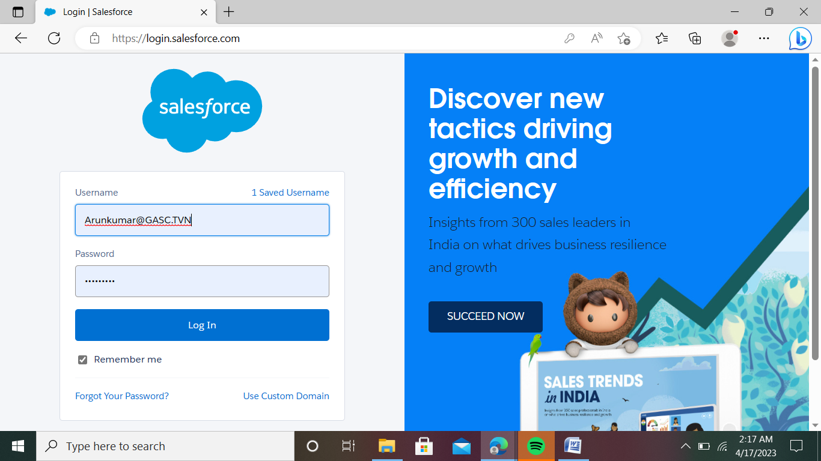

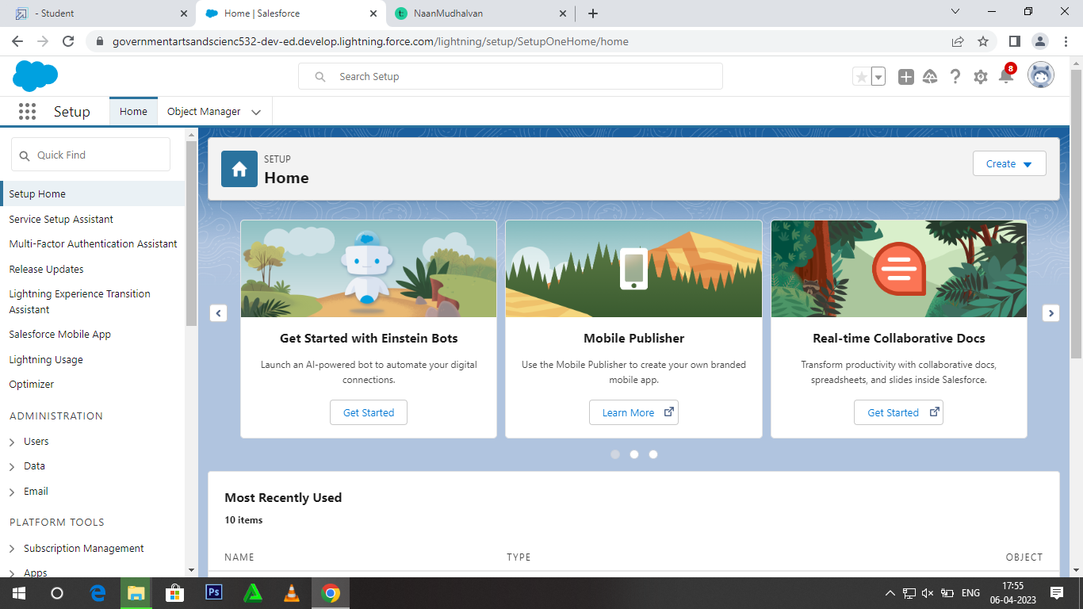

Milestone-2: Object

Activity-1: Creation of school Object

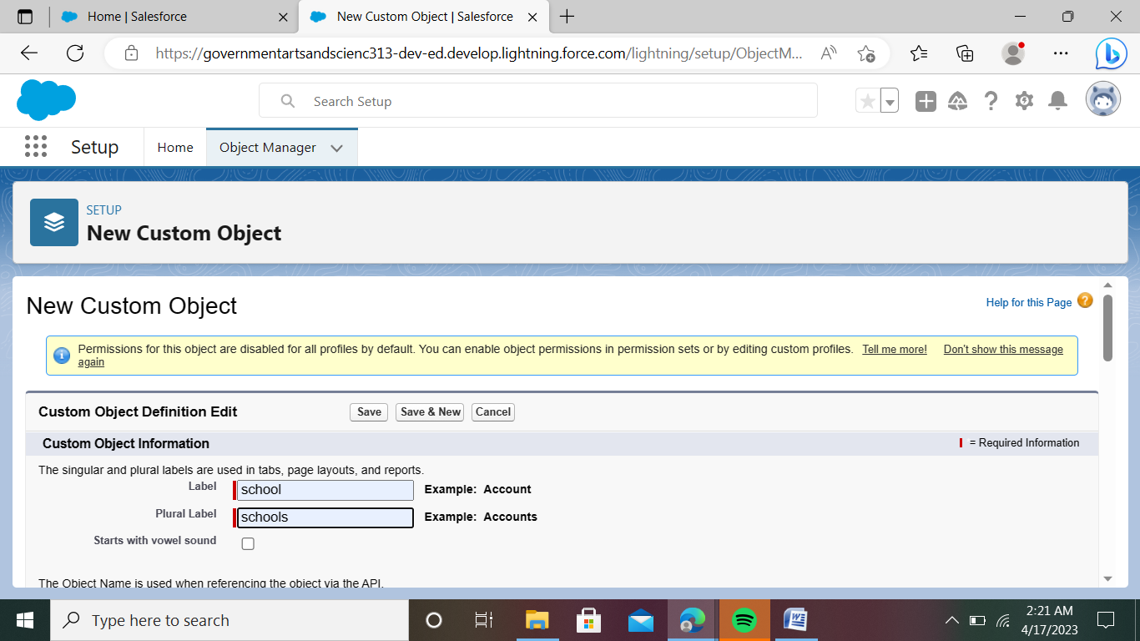

Activity-2: create student object

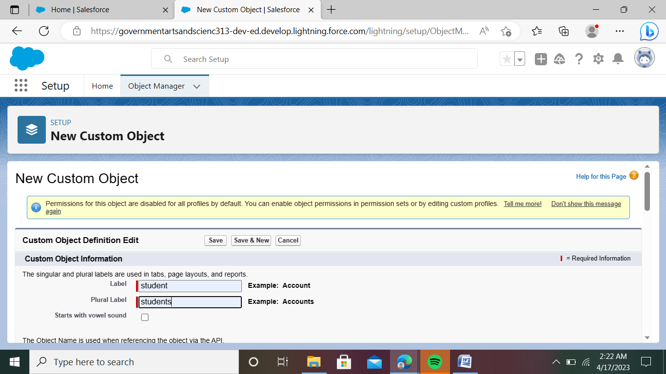

Activity-3: create parent object

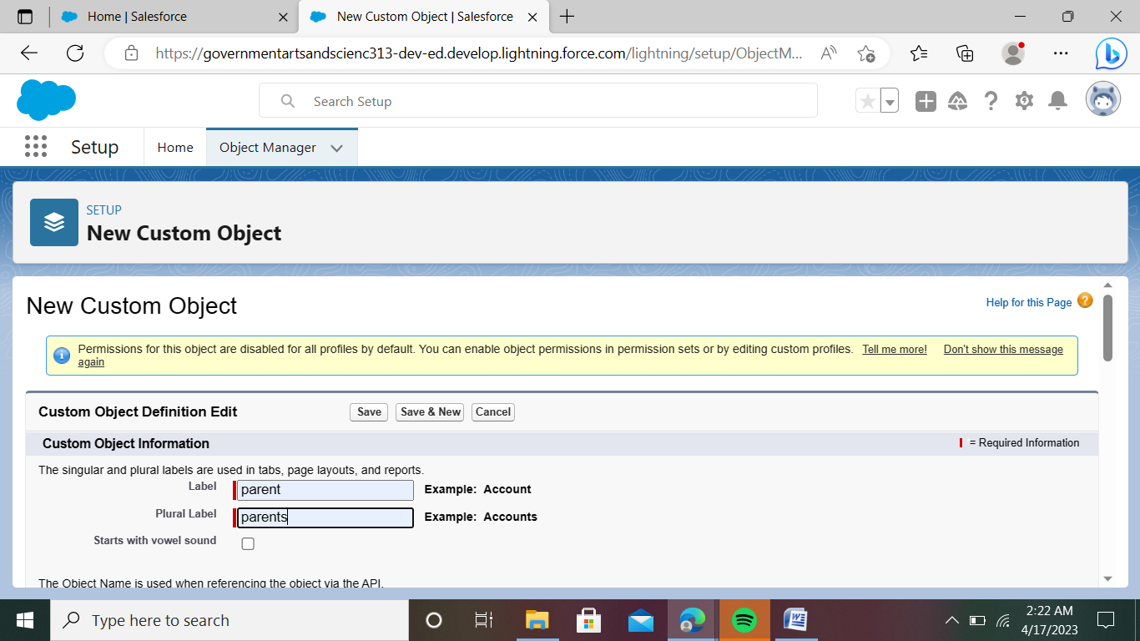

Milestone-3: Lightning App

Activity:

Create the school Management app

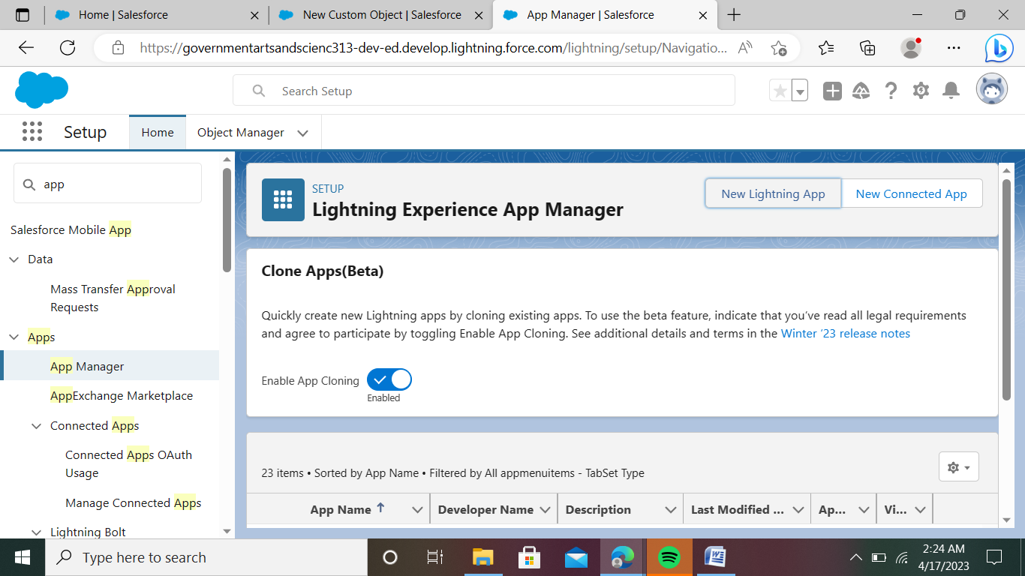

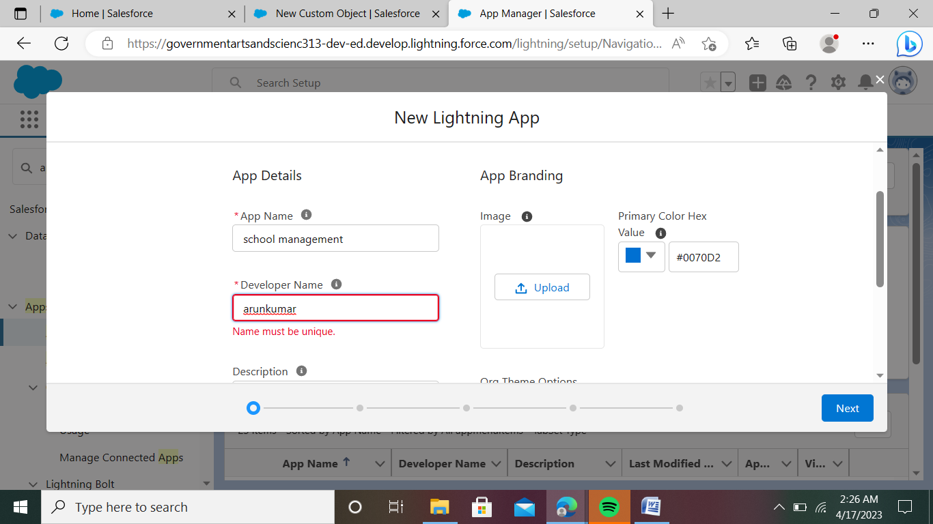

Milestone-4: Fields and Relationship

Activite-1:

Creation of fields for the School object:

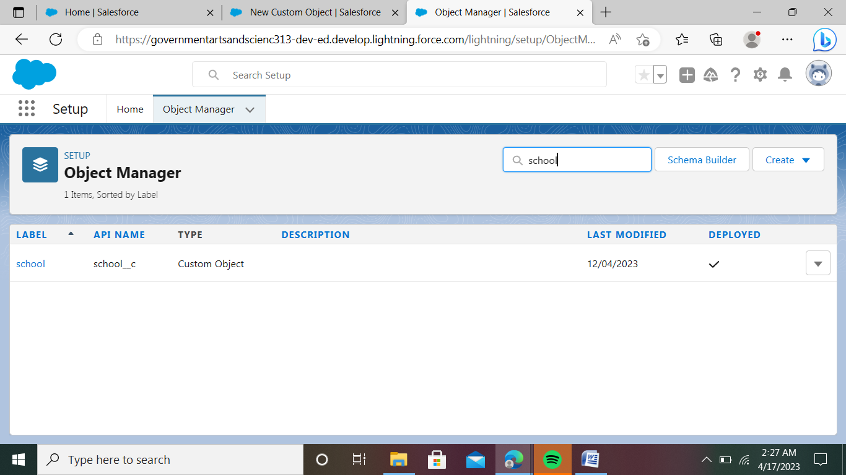

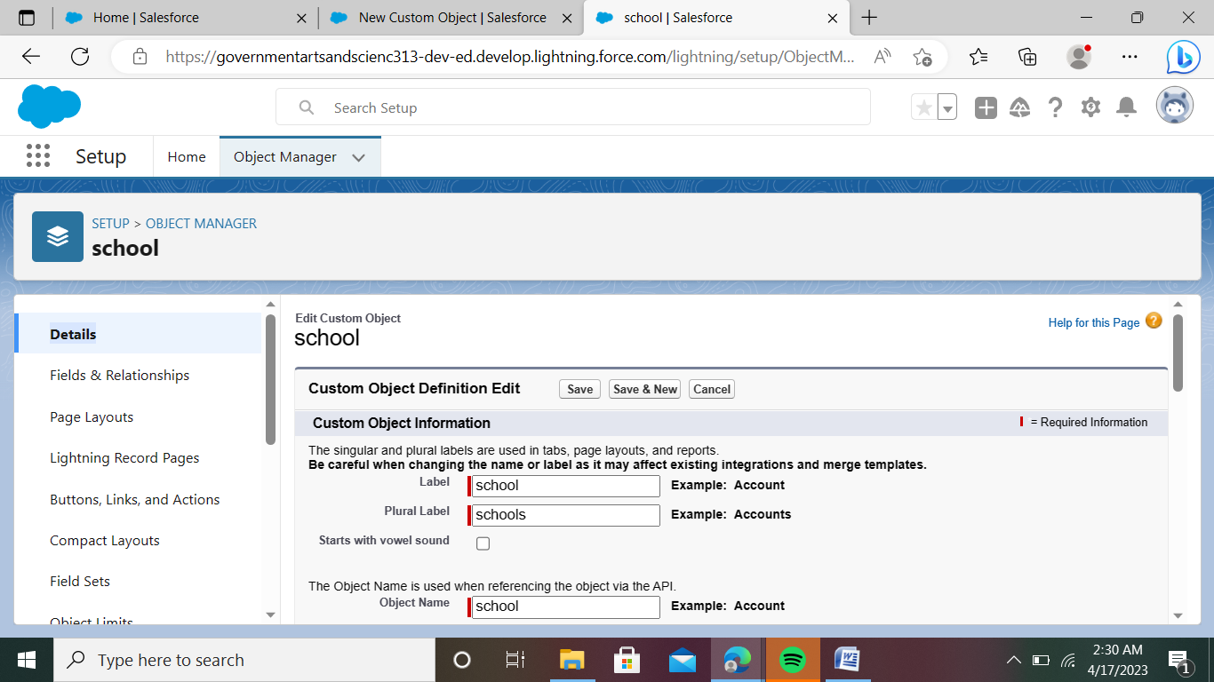

Activity-2:

Create of fields for the Studentobject:

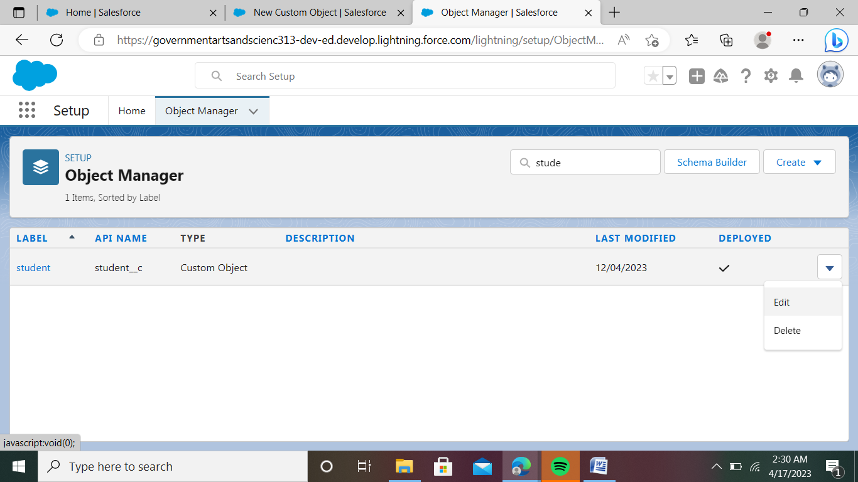

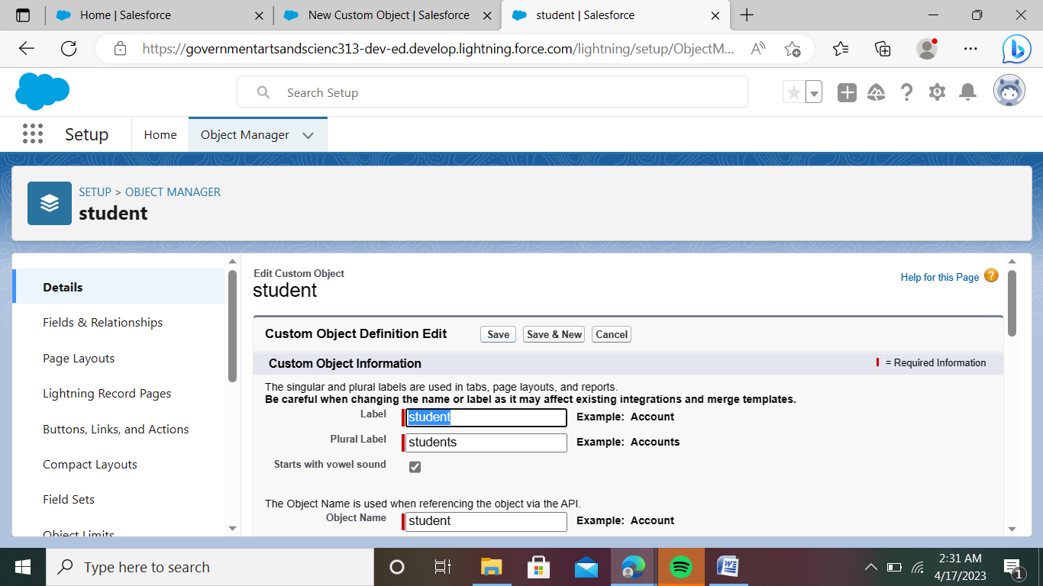

Activity-3:

Creation of fields for the Parent objects:

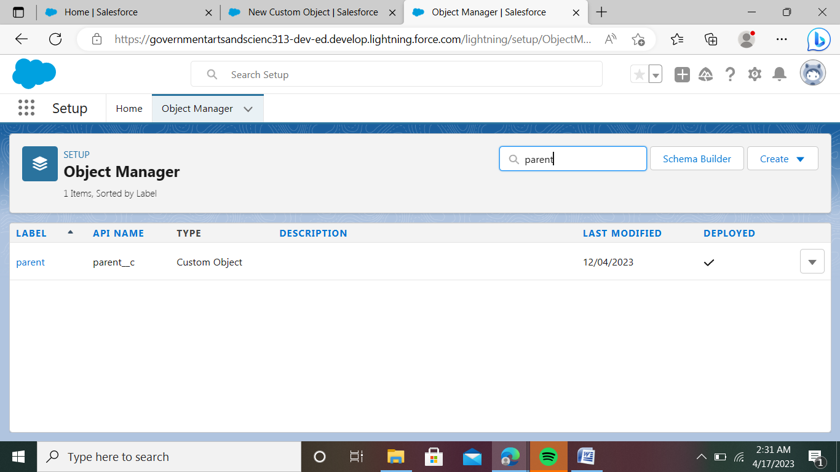

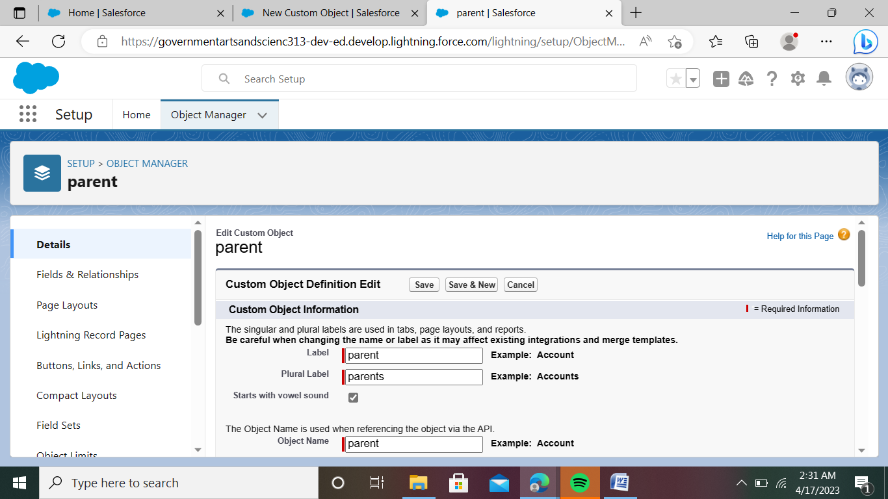

Mileston-5: Profile

Activity:

Creation on Profile:

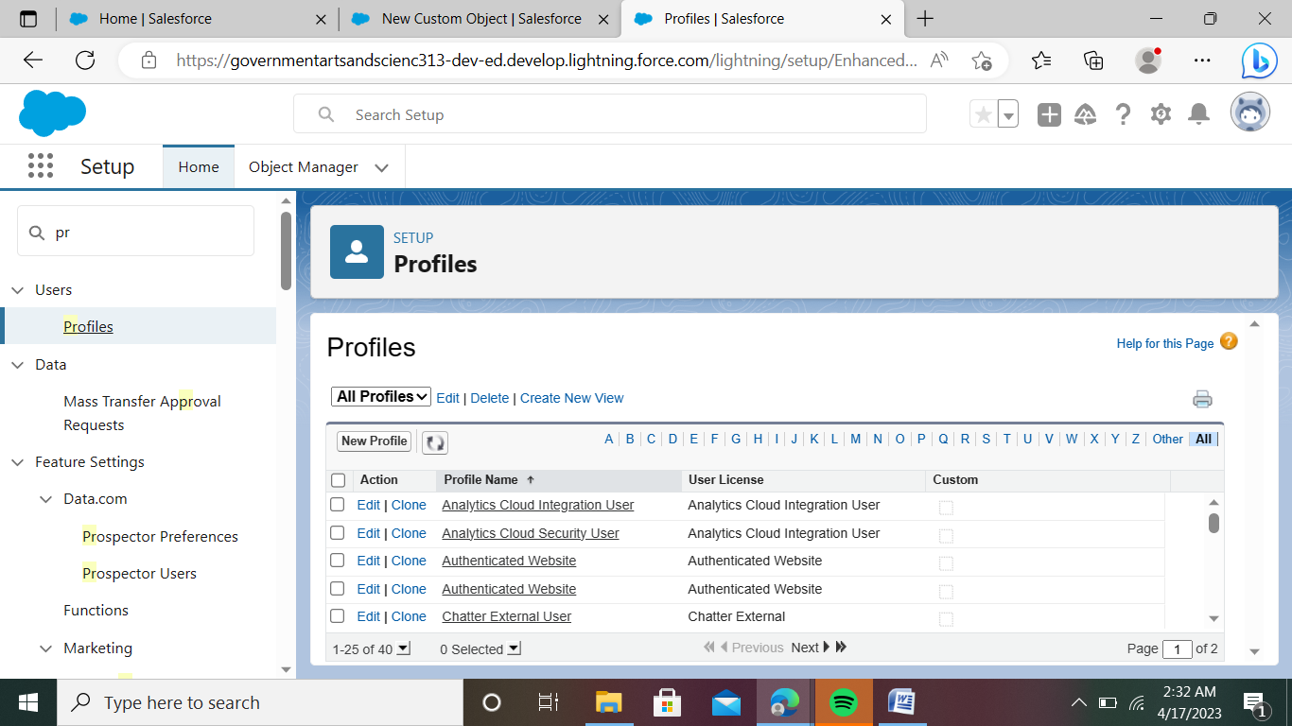

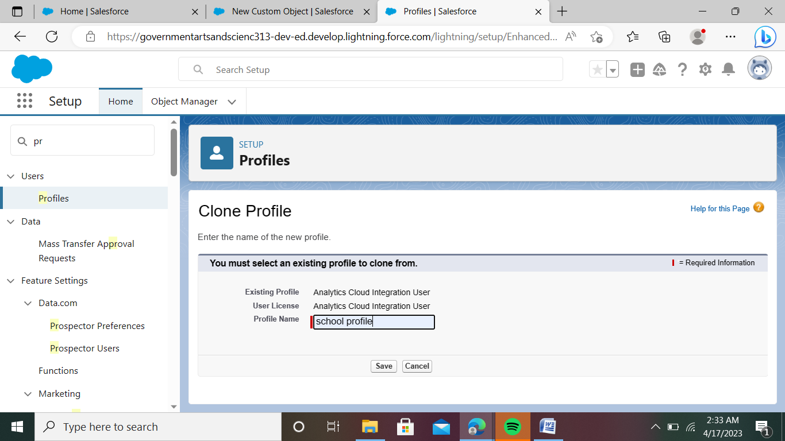

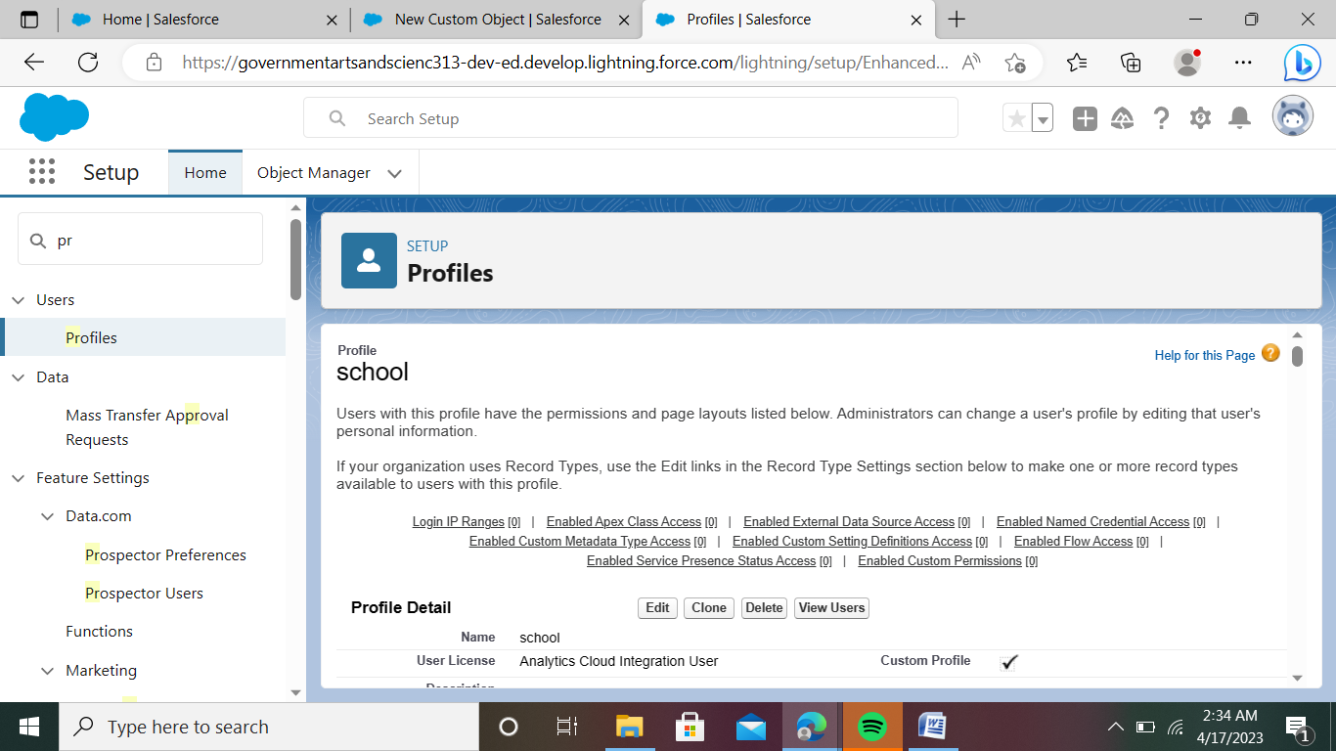

Milestone-6: Users

Activity:

Creating a users:

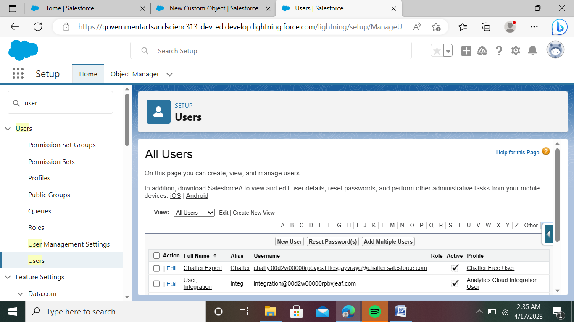

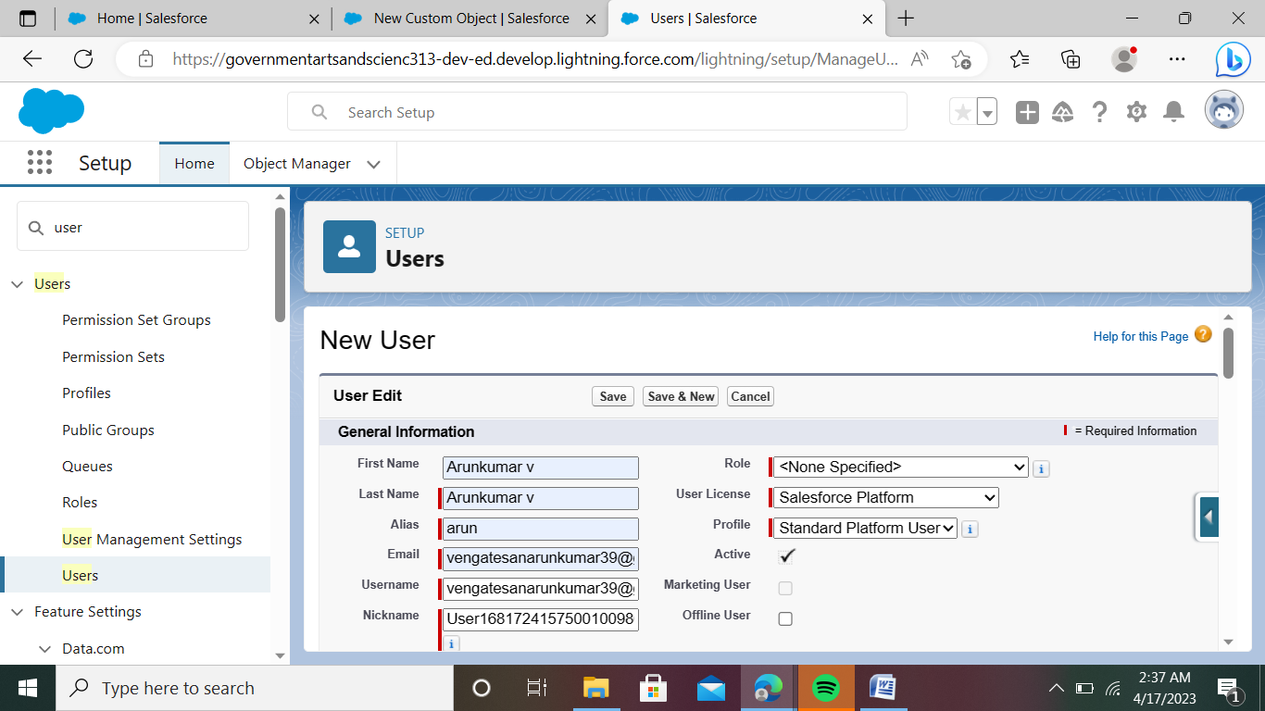

Milestone-7: Permission sets

Activity-1:

Permission sets:

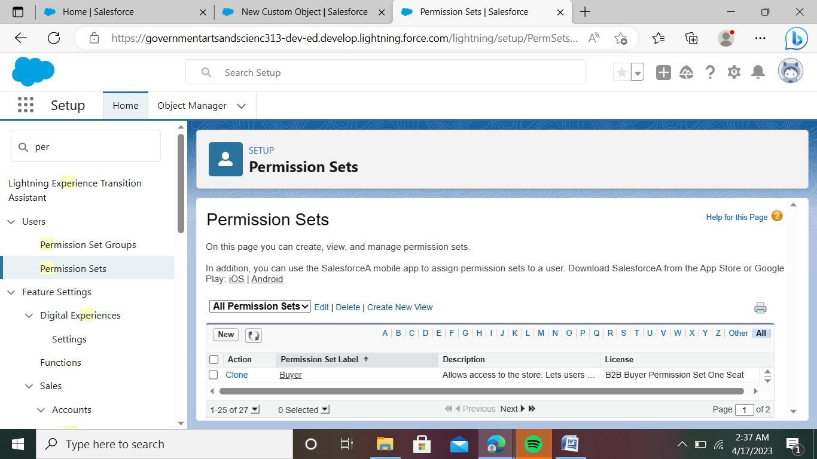

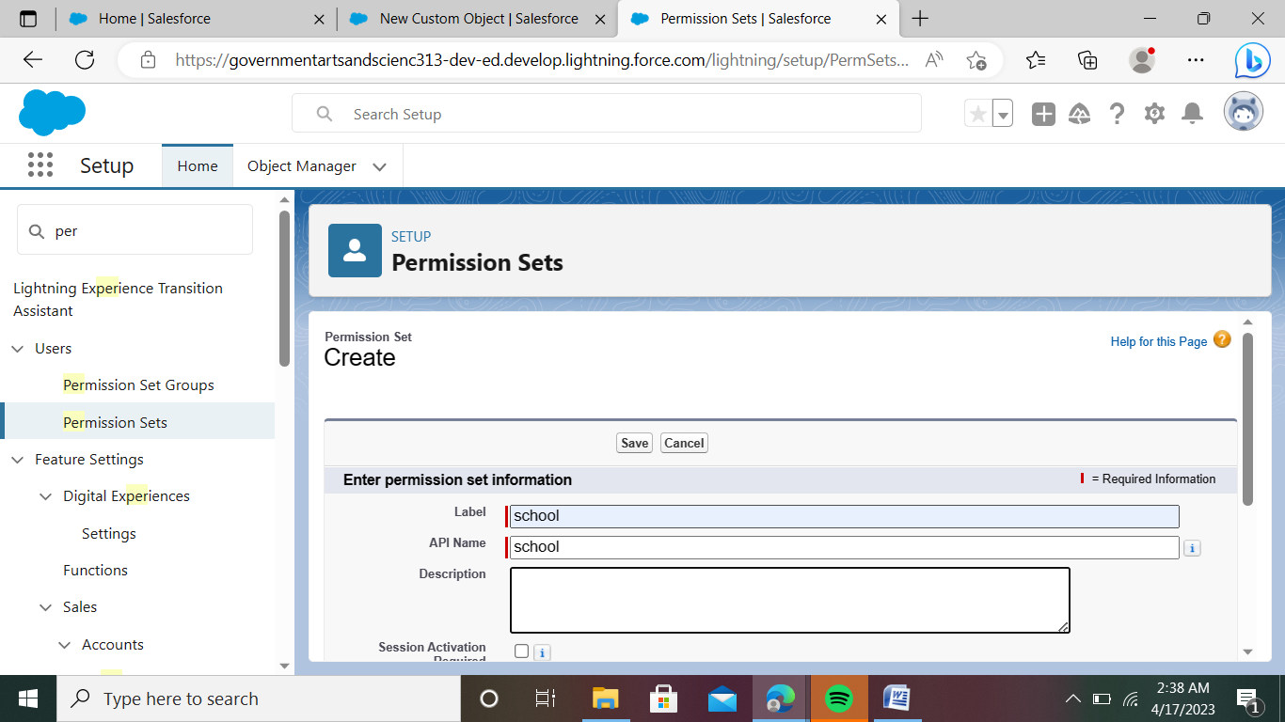

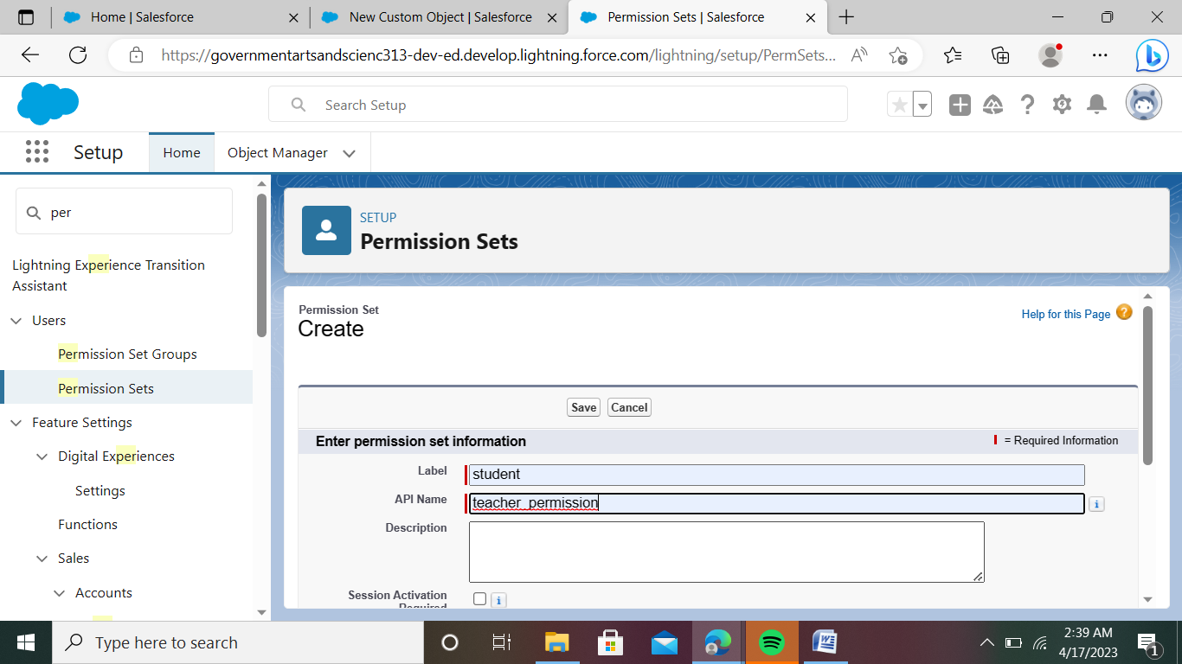

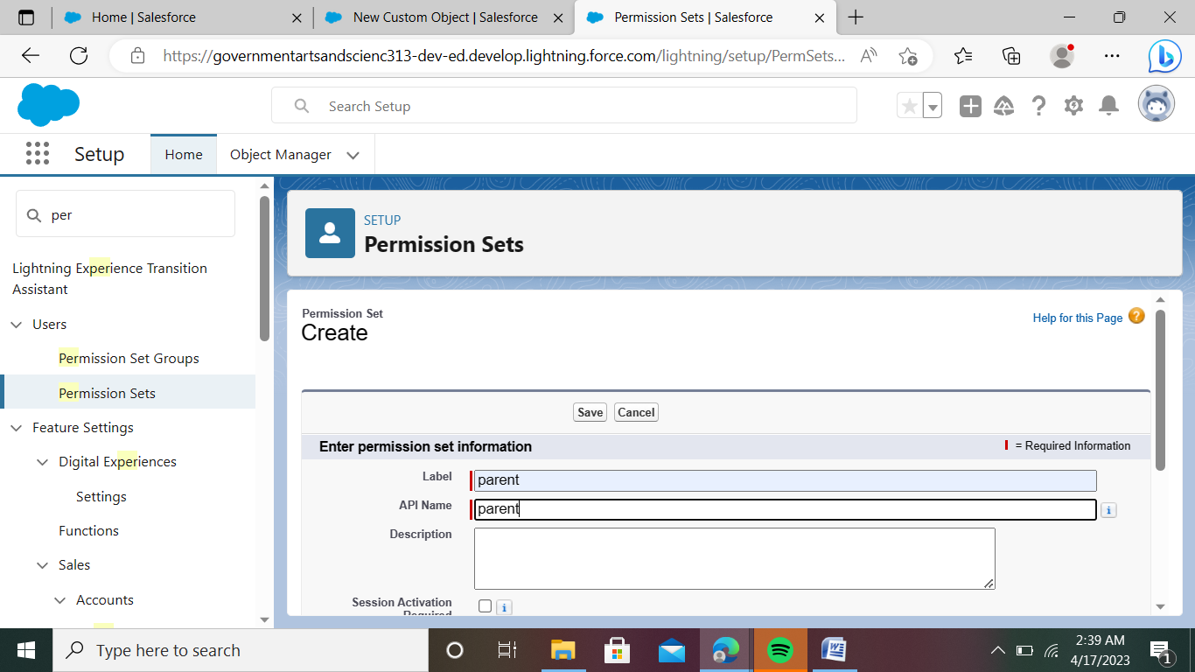

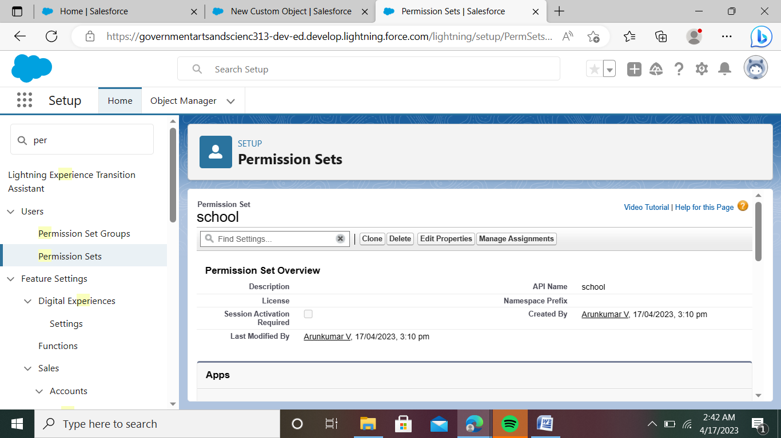

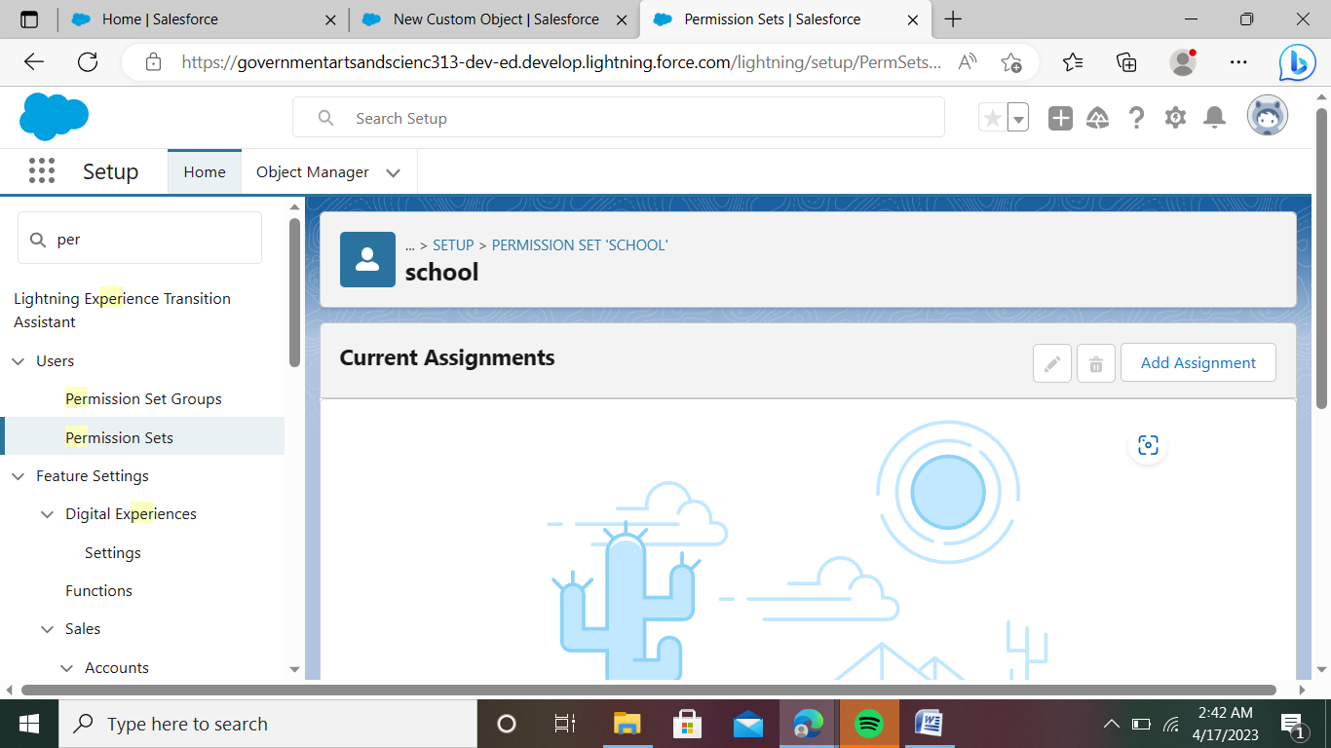

Activity-2:

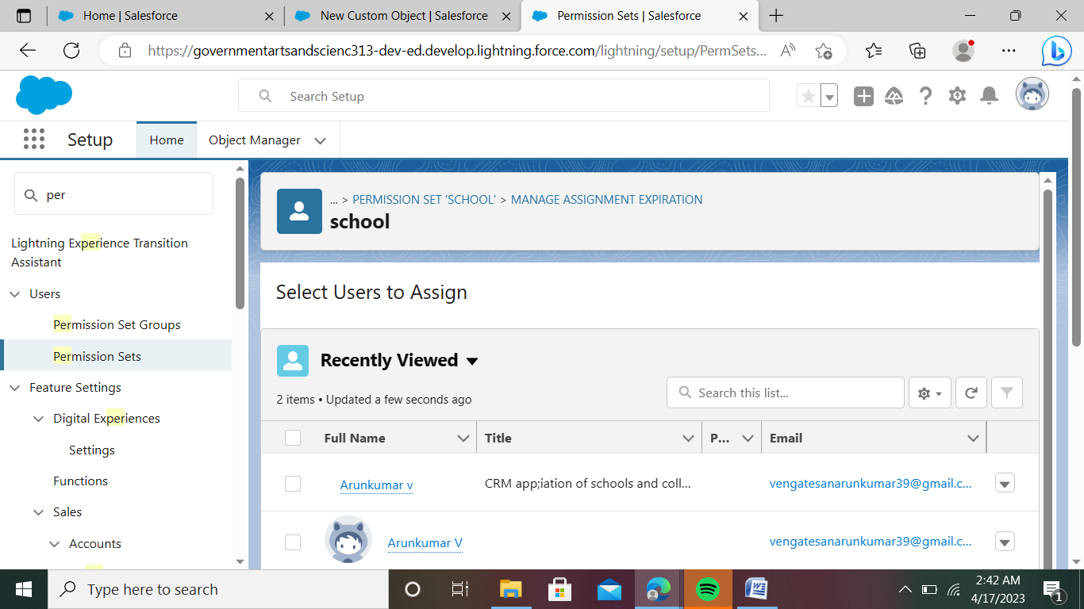

Milestones-8: Reports

Activity :

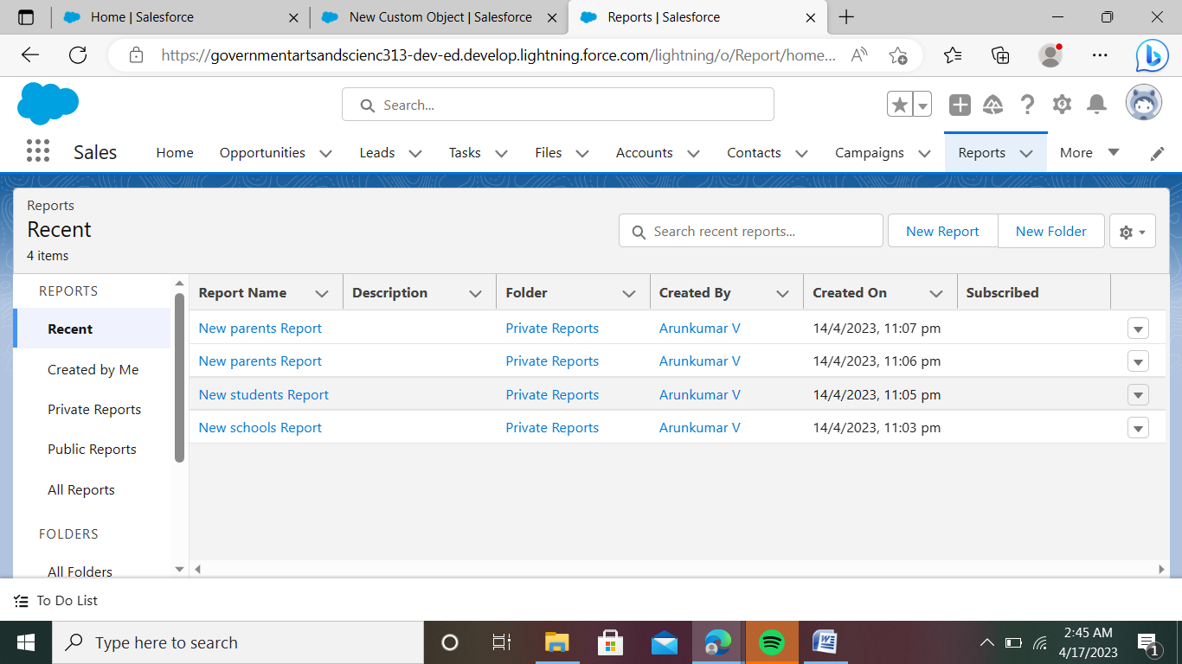

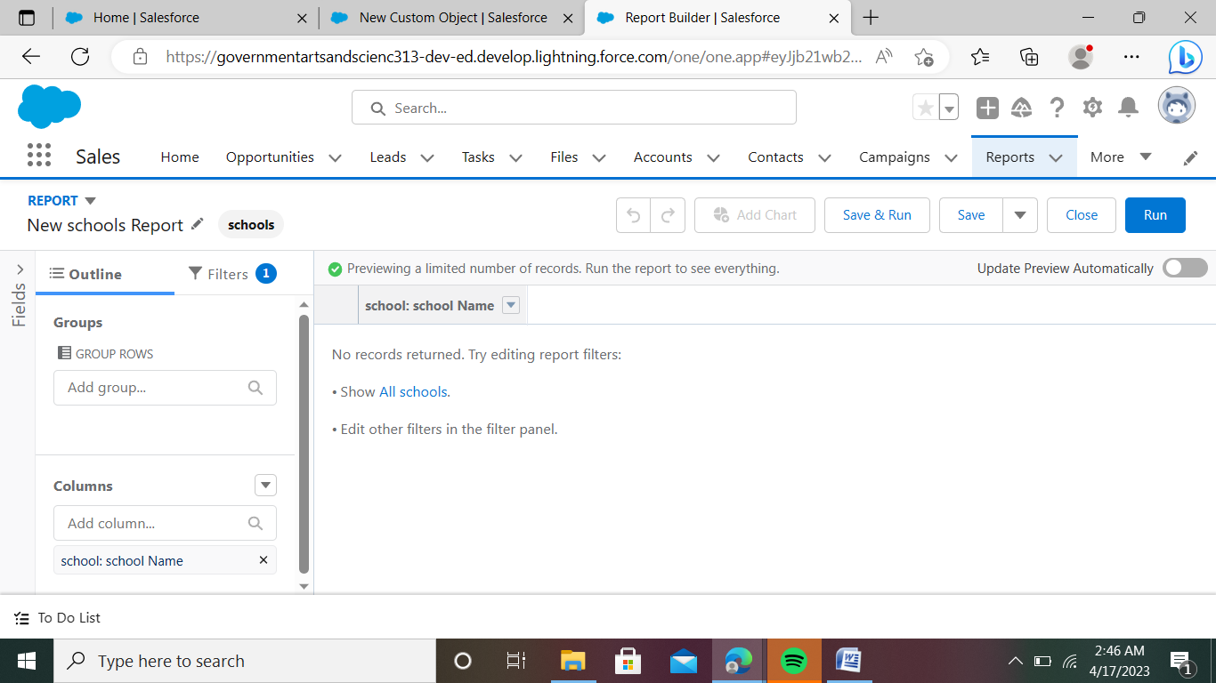

4. TRAILHEAD PROFILE PUBLIC URL

Team Lead - <https://trailblazer.me/id/aarunkumar19>

Team member 1 – <https://trailblazer.me/id/aravind48>

Team member 2 – <https://trailblazer.me/id/apapa135>

Team member 3 - <https://trailblazer.me/id/abiabi111>

5. ADVANTAGES & DISADVANTAGE

ADVANTAGES

* outer world which they have never experienced before.
* Students become much more responsible as there is no one to look after them.
* Teachers in college and universities are much more experienced than the conventional teachers so the students can gain much knowledge fro  them.
* Students get to know about real competition in the outer world and thus making Students get an experience of the them more focused towards their goal.

DISADVANTAGES

* Students might get influenced by their peer group and might get into wrong activities.
* College is a platform where students experience much more freedom than before and thus misuse it.
* Students might get into relationships which might hamper their studies.﻿

6. APPLICATIONS

Job Description Human Resources Assistant, Human Resources (HR) Assistant is a professional who is responsible for the daily administrative and HR duties of an organization. They assist with recruitment and record maintenance for payroll processing as well as provide clerical support to all employees

7. CONCLUSION

Study began with a basic curiosity of researcher based on academic exposure in HR and some questions raised in the mind after getting work exposure in development sector. Field of Human Resource Management has gone through an evolution process and has started playing a strategic role in industries. Generation of knowledge in HR has happened mainly on the basis of requirements in industrial sector.

Development Sector Organizations that are Non-profit in nature and also comparatively smaller in employee strength have not been much in to consideration while generating this knowledge. Thus concepts and principles of HR based on this knowledge may have relevance in this sector but while implementing them, contextual understanding is required.

8. FUTURE SCOPE

The scope is always high, request you to learn more and more about the techniques of recruitment this will help you in industry. Scope for HR is promising, there are many specialities in HR you can choose to master your career in. Recruitment is one of the speciality most sought after by consultancies and corporate